**Activity 2**

Identity

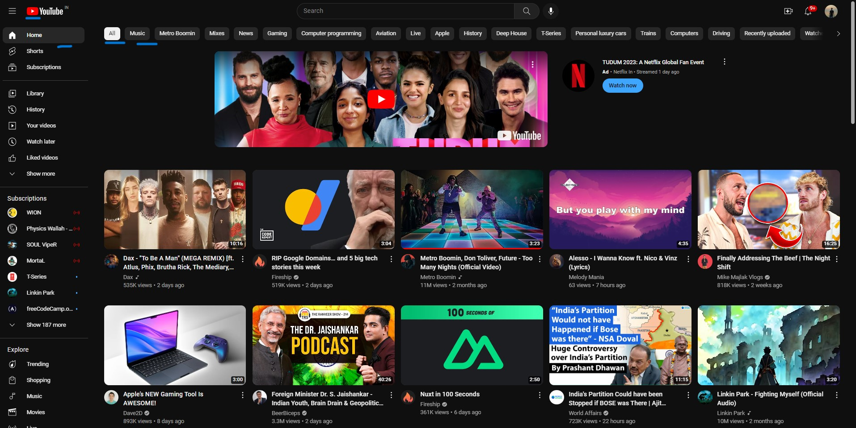

Identity here can be described as the theme color like the red , White, gray and black.

Elements

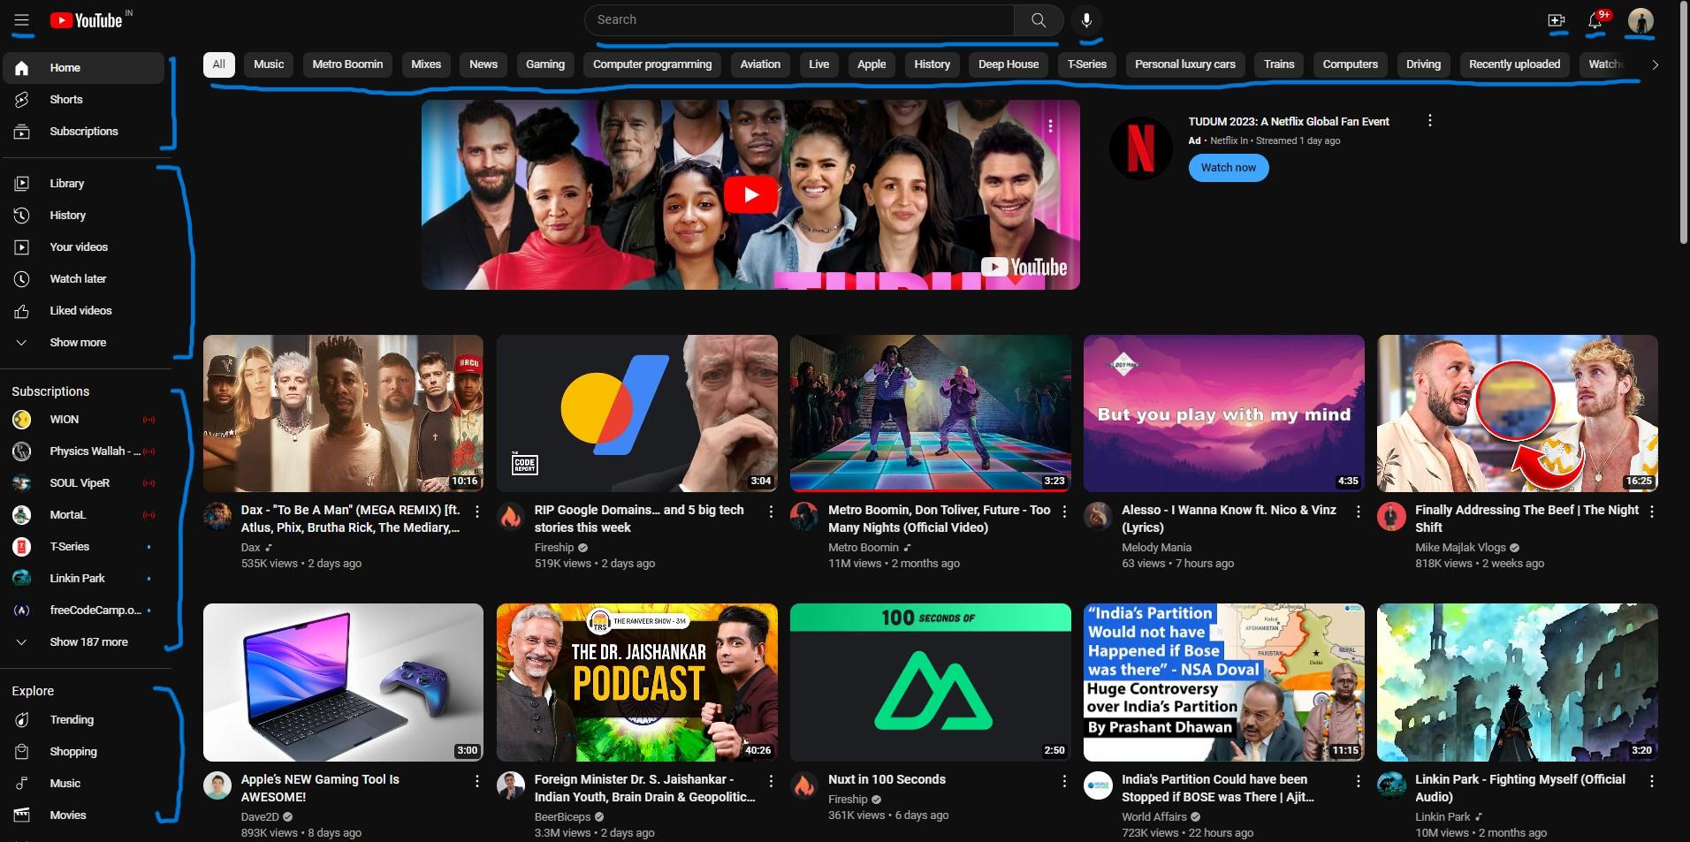

Elements are things like: buttons, links, inputs, drop-downs etc.

Components

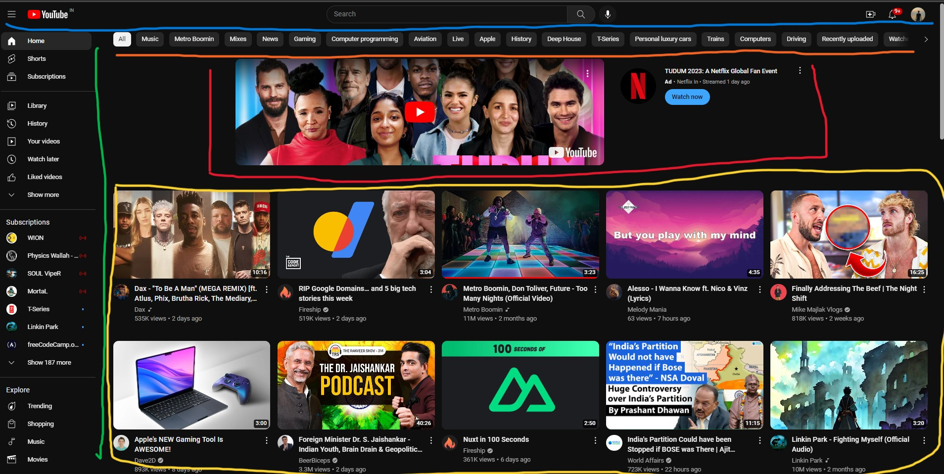

Here we can describe components like:

Blue: Navbar,

Orange: Categories bar,

Green: Sidebar,

Red: Advertisement Component,

Yellow: Video Component.

Note: The video component can also be a composition.

Compositions

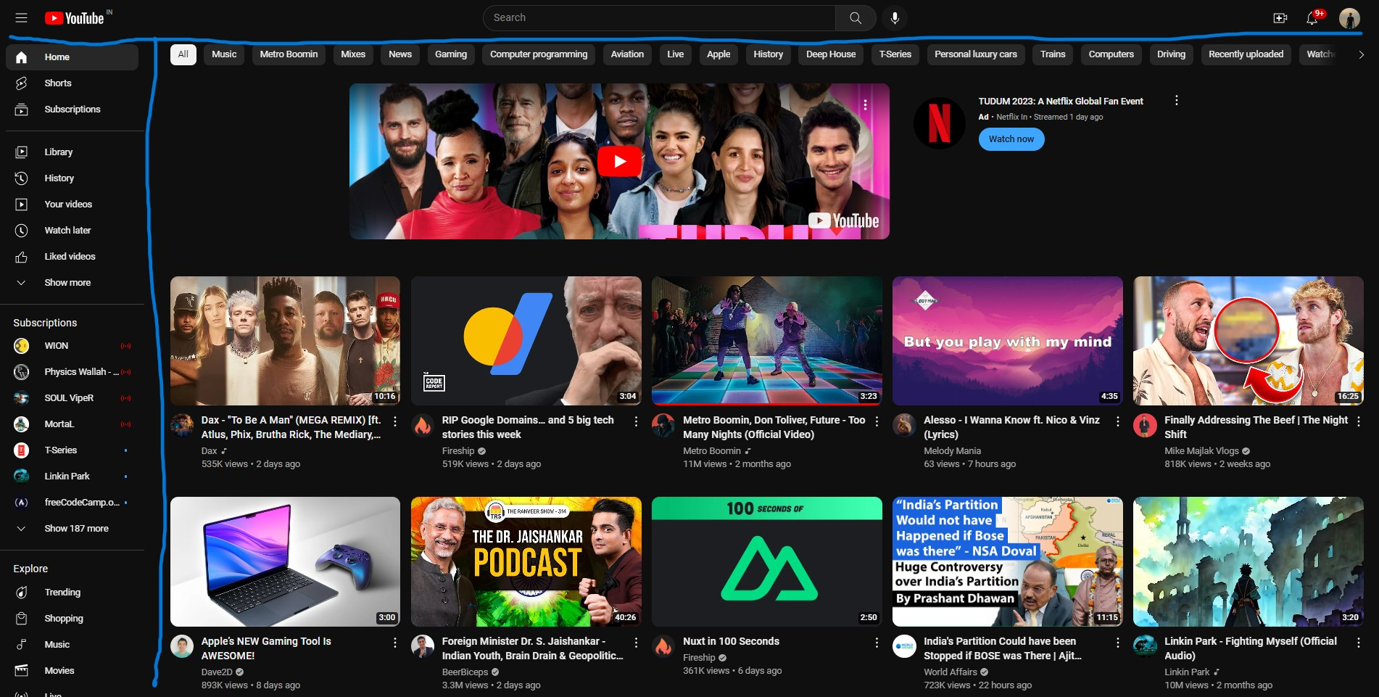

Here we can broadly classify 3 compositions, the navbar, the sidebar and all the contents in the center.

Layout

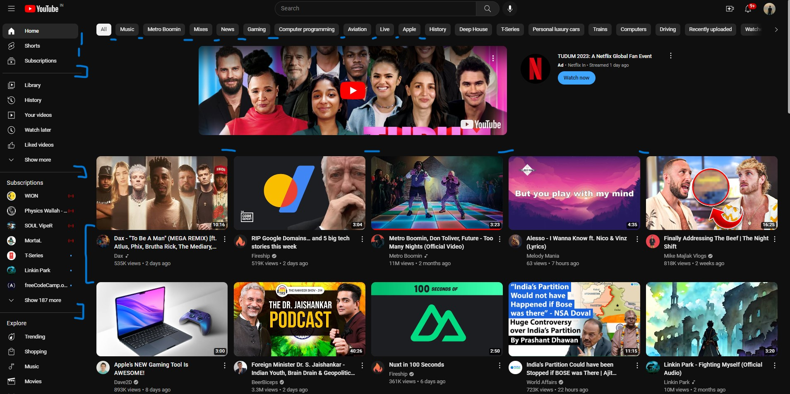

Here the layout can be described as the space between different elements, components and compositions.

Pages

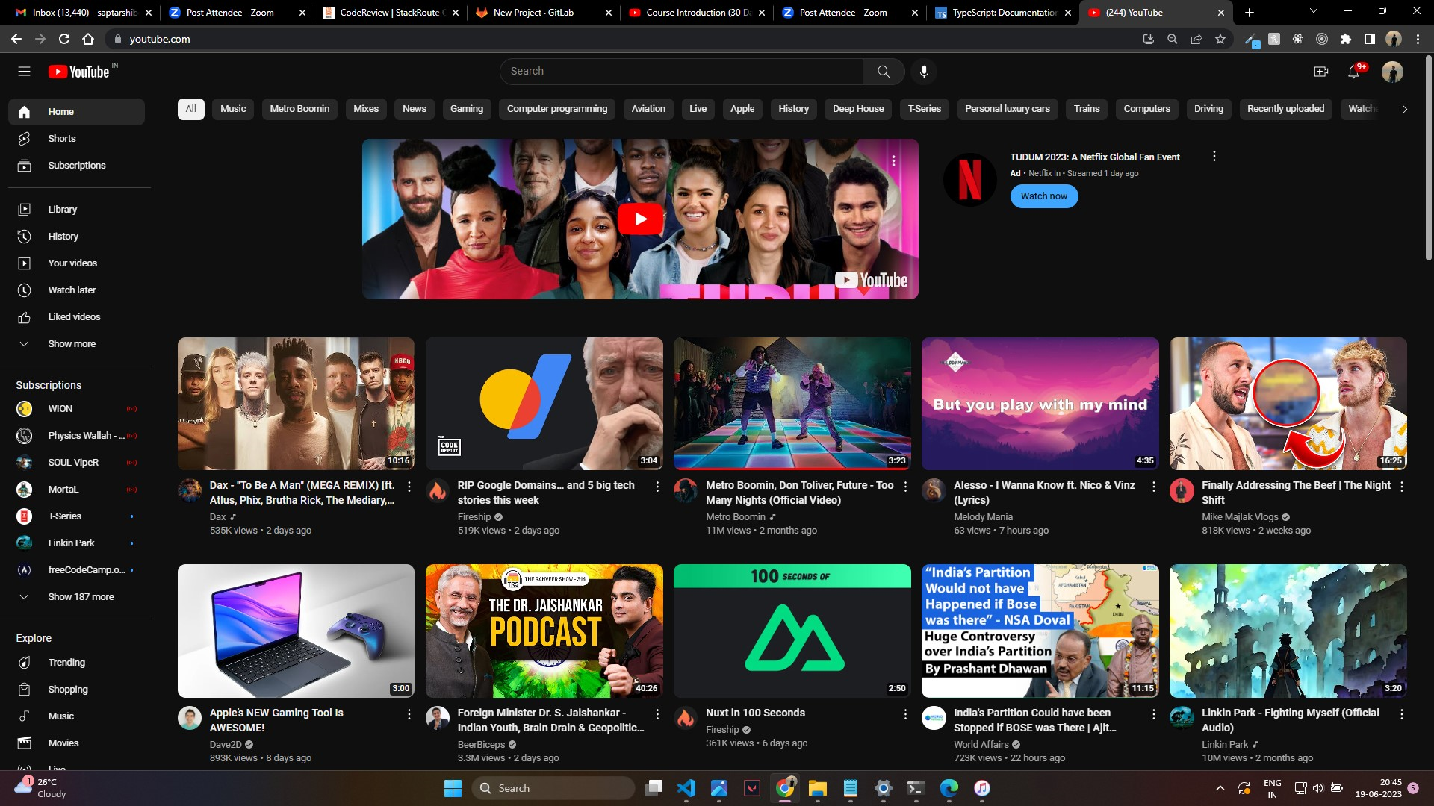

Here Identity, elements, components, compositions, layout everything coming together where the user can interact is call a page.